**Kubota Warranty Lookup (KUBL):** This program allows you to look up warranty information on any piece of Kubota equipment. **NOTE:** This program is only available to **U.S. Kubota** dealers.

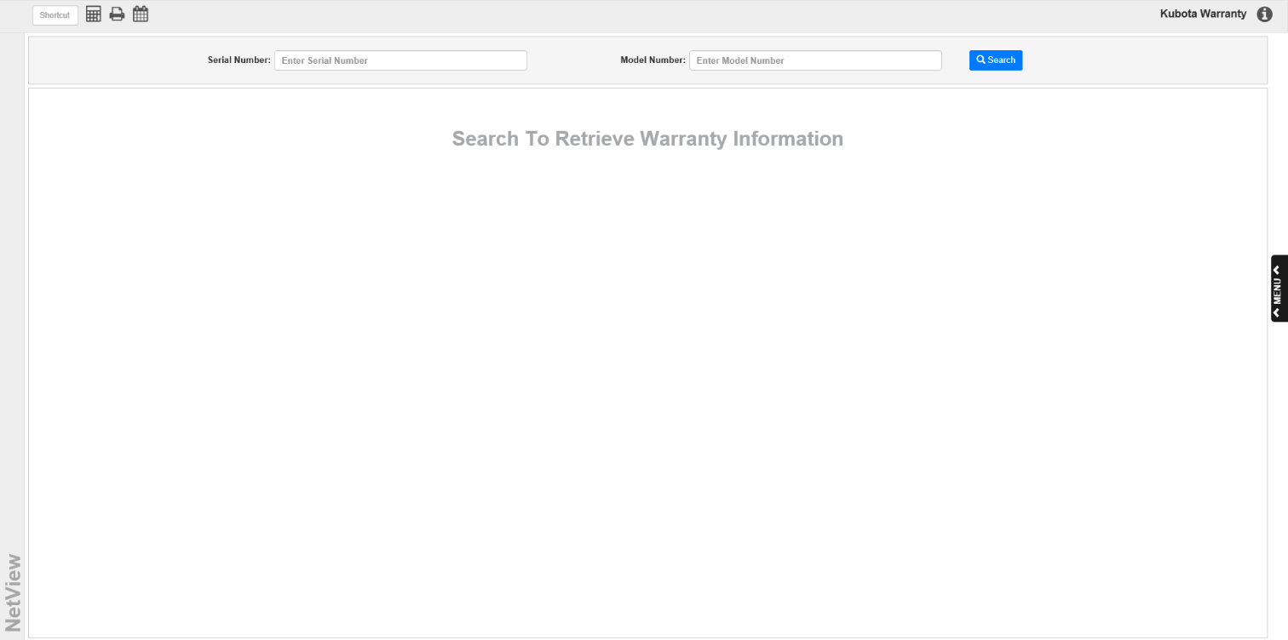

**Serial Number:** Enter the serial number of the Kubota equipment here.

**Model Number:** Enter the serial number of the Kubota equipment here. You can enter a full or partial model number.

**Search:** Click this button to look up the warranty information. If the search returns more than one results (likely in the case of a **partial** model number), you will see the following window appear:

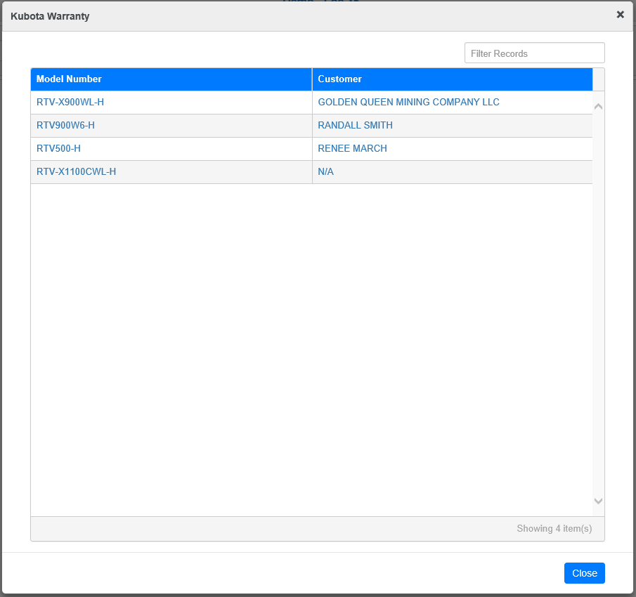

Click on an entry to view its warranty information.

However, if there is only one matching result found (from entering a **full** model number to go with the serial number), the warranty information for that particular piece of equipment will automatically appear on the screen.

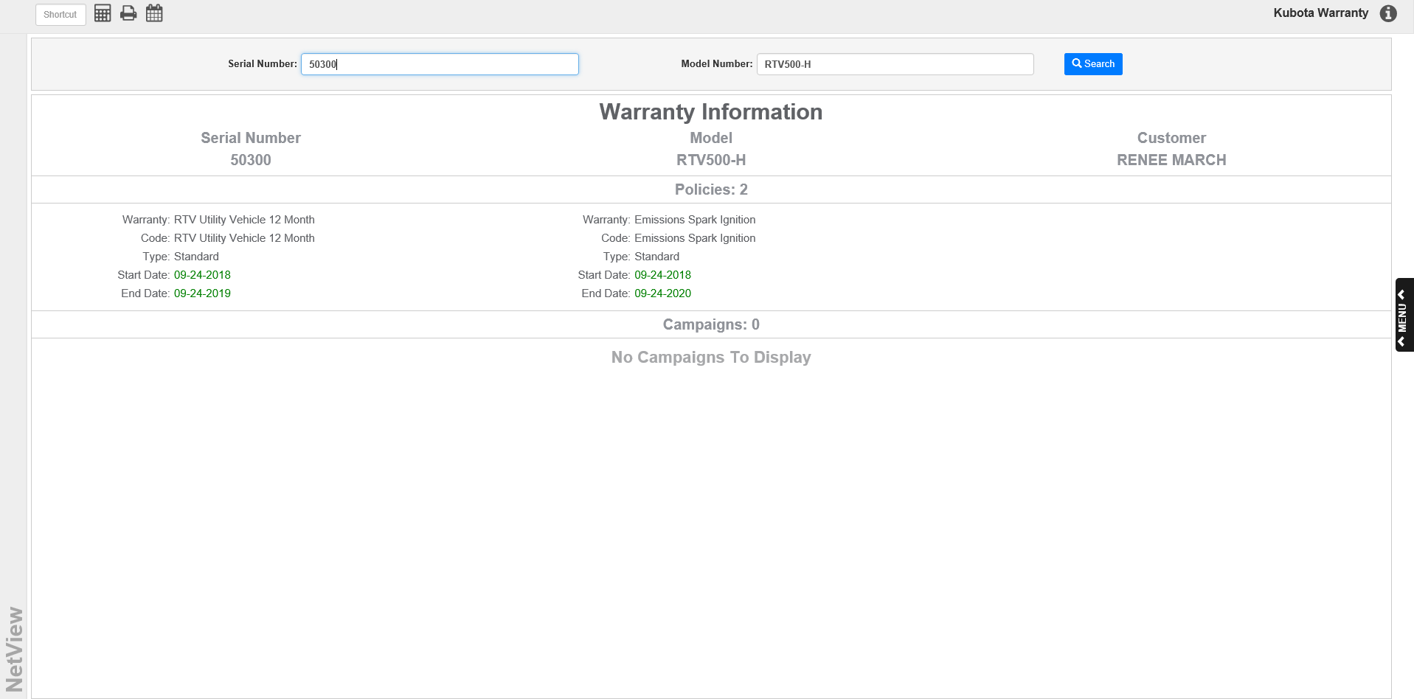

Alongside the serial and model numbers, the information screen will list the warranty customer, any warranty policies currently taken against the equipment, and any related promotional campaigns (such as coupons offered).

**Kubota Warranty Lookup ActiveTile:** You can also perform the lookup on your Desktop using the Kubota Warranty Lookup ActiveTile. You will find it in the **Active Apps** section of the **ActiveView** tab on the main Menu. Click on the tile name, then drag and drop it to the Desktop to create it.

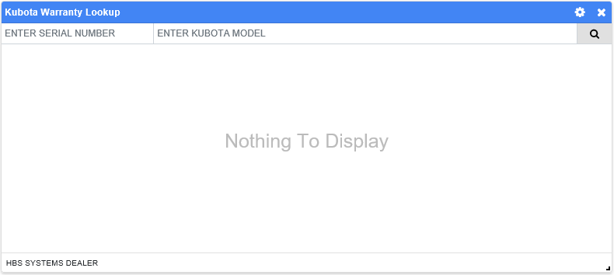

Enter the serial number and model number as you would in the normal program, then click the **Search** button. The result will be the model number and the customer name. Note that if you enter a **partial** model number, you will likely get multiple results, as in the main program, whereas entering a **full** model number will return only one result.

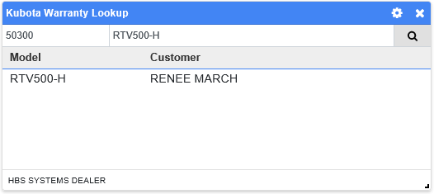

Click on the entry to view the warranty information as displayed in the main program.

